Nils Dücker – 3D Artist

Shipped Games:

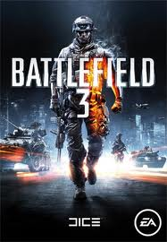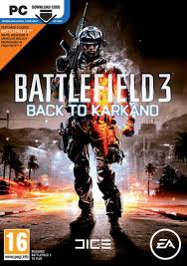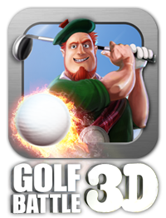

Resume:

I am a professional 3D artist based in Sweden with 3 years experience in the game industry in both in-house developer roles and freelance art outsourcing, and have a vocational degree in game art.

I am a technically inclined person and enjoy working with systems such as character customization,
microdestruction, vehicle systems like suspensions and cockpits, shader networks as well as pure artistic modelling/texturing work. I also have a keen interest in optimizing assets for performance
and have experience doing this across multiple platforms, from handhelds to consoles.

Employment:

Tarsier Studios, Karlshamn Sept 2012- Feb 2013
- 3D artist on DLC packs for Little Big Planet 2, Little Big Planet Vita and Little Big Planet Karting
- Modeling , texturing and rigging assets to match a unique visual style
- Focus on modular character outfits and modular vehicles
- Strong focus on producing highly optimized content with fast turnaround
- Porting of finished assets across console/handheld platforms with maintained visual fidelity
- Good knowledge on porting assets between different game engines
- Setting up scenes and materials for efficient 3D to 2D rendering pipeline
- Rendering of assets for promotional artwork and special requests
- High, mid and low poly modeling
- Emphasis on efficient workflows for baking high to low poly, unwrapping and texturing

Goldhawk Interactive (Freelance) Jan 2012 – Aug 2012
- 3D artist on Xenonauts
- Modeling and texturing assets to match a unique visual style
- Setting up scenes and shaders for efficient 3D to 2D rendering pipeline
- High and mid poly modelling

Rising Storm (Freelance) Feb 2012 – June 2012
- Environment/prop artist on Rising Storm
- Modeling and texturing assets to match historical references
- Unreal 3 pipeline
- Optimizing assets

EA Digital Illusions CE AB, Stockholm Aug 2011 – Jan 2012
- Technical Artist on Battlefield 3 and Battlefield 3: Back to Karkand
- Object modeling and texturing
- Adding destruction to assets
- Content optimization
- Node based shader creation
- Creating and tweaking effects
- Bug testing and fixing
- Using Perforce production line and Jira bugtracking tools

Imperial Game Studio, Malmö Feb 2011 – May 2011
- Concept and 2D/3D art for an unreleased project
- Modelled and textured highpoly assets
- Used highend 3D assets to make ingame sprites and cinematics

Imperial Game Studio, Internship, Malmö Aug 2010 – Feb 2011
- Lead artist on Turbogrannies
- Lead environment artist and character rigger on Golf Battle 3D
- Designed character customization system for Golf Battle 3D
- Modelling, texturing, rigging, lighting and additional animation on Golf Battle 3D CG trailer
- Developed skills in Modo as well as Airplay SDK for mobile platforms
- Experience with Iphone, Android, Samsung Bada, PowerVR och ATI texture compression
- Extensive experience working under an art director in a production pipeline
- Good skills in meeting high graphical targets in OpenGL ES 1.0+

Education:

The Game Assembly Vocational School, Malmö Sep 2008 – Feb 2011
- Extensive knowledge of Maya, 3D Studio Max, Photoshop, ZBrush
- Extensive knowledge of implementing 3D and 2D assets into game engines.
- Extensive experience in game production and setting up art pipelines
- Experience using agile development methods and iterative production
- Cooperation with coders during tool development and asset optimization
- Familiarity with tools and plugins such as: Xnormal, Havok Physics Tools, Compressonator, UDK, CGFX, Tortoise SVN.

Languages and other Merits:

Swedish: Native speaker
English: Fluent written and verbal
Drivers license for car and forklift
Served in the Royal Swedish Navy 2001-2002 as radar operator and cryptographer.

References:

Lennie Axelsson, Lead Artist, Tarsier Studios, lennie.axelsson@tarsier.se,
Andreas Persson, Outsourcing Manager, Tarsier Studios, andreas.persson@tarsier.se
Fredrik Ulfves, Senior Artist, EA DICE, Fredrik.Ulfves@dice.se, +46763224264
Jhony Ljungstedt, Art Director, EA DICE, Jhony.Ljungstedt@dice.se
Johan Dalborg, Development Manager, EA DICE, Johan.Dalborg@dice.se
Rick Underhill, Level Artist, EA DICE, Rick.Underhill@dice.se
Martin Flensburg, CEO, Imperial Game Studio, martin@imperialgamestudio.com , +46768906207
Mikael Blyborg, Work colleague +46705770430

